**Farnham Lions update**

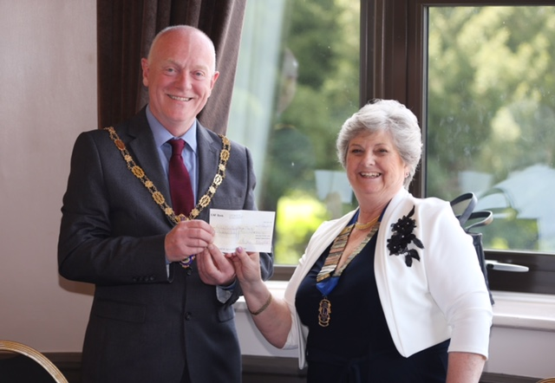The members of the Lions Club of Farnham recently held its annual Charter dinner at the Hogs Back Hotel attended by its members and guests to mark the start of a new Lions year and change of Lions President.

Photographed below is the outgoing president Barbara Wright pictured with Councillor Mike Hodge, the newly appointed Farnham Town Mayor. Councillor Julia Potts also attended as the Mayor’s Consort.

The Lions Club of Farnham was established in 1968 and so this charter marked the start of its 50th year of service to our community and the start of a year of celebrations and special events all of which are planned to add further support.

During this millennium alone over a million pounds has been raised to support good causes via activities such as Beerex, the Easter Eggstravaganza, Project Wenceslas, The Farnham Carnival and much more.

On July 8th the Farnham Lions Summer Spectacular, attended by 700 guests, will be as the name suggests a ‘spectacular event’ with all of the proceeds being shared by The Ridgeway School, 40 Degreez, Frensham Pond Sailability and Challengers. There are now less than 40 tickets still available.

To find out more please visit:www.farnhamlions.org.uk/summerspectacular.

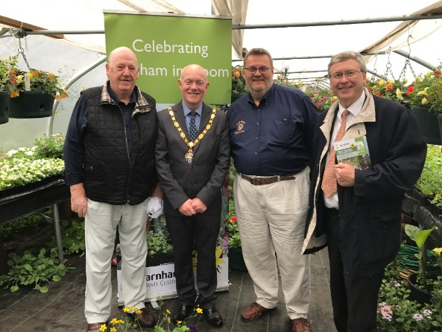Along with fellow Lions Keith Harris and Geoff Jeal, incoming President Andrew Lodge met with Councillor Mike Hodge , the Farnham Town Mayor recently at the launch of this year’s Farnham in Bloom of which the Lions Club of Farnham is a supporter. Andrew, who was Lions President during 1988-89 is very much looking forward to this special year leading up to the 50th.